Assembling PEEK-A-BOO HEART Valentine to Mail
You’ll need scissors and glue or tape.

Cut, fold, and glue or tape envelope.

- Print out card and envelope.
- Cut out envelope shape and fold. Use your favorite glue or tape to fasten envelope tabs. A simple glue stick (available in office supply and school supply aisles at many stores) works well. You might want let the glue dry overnight.

Cut out card as shown below.

Trim heart shape. | 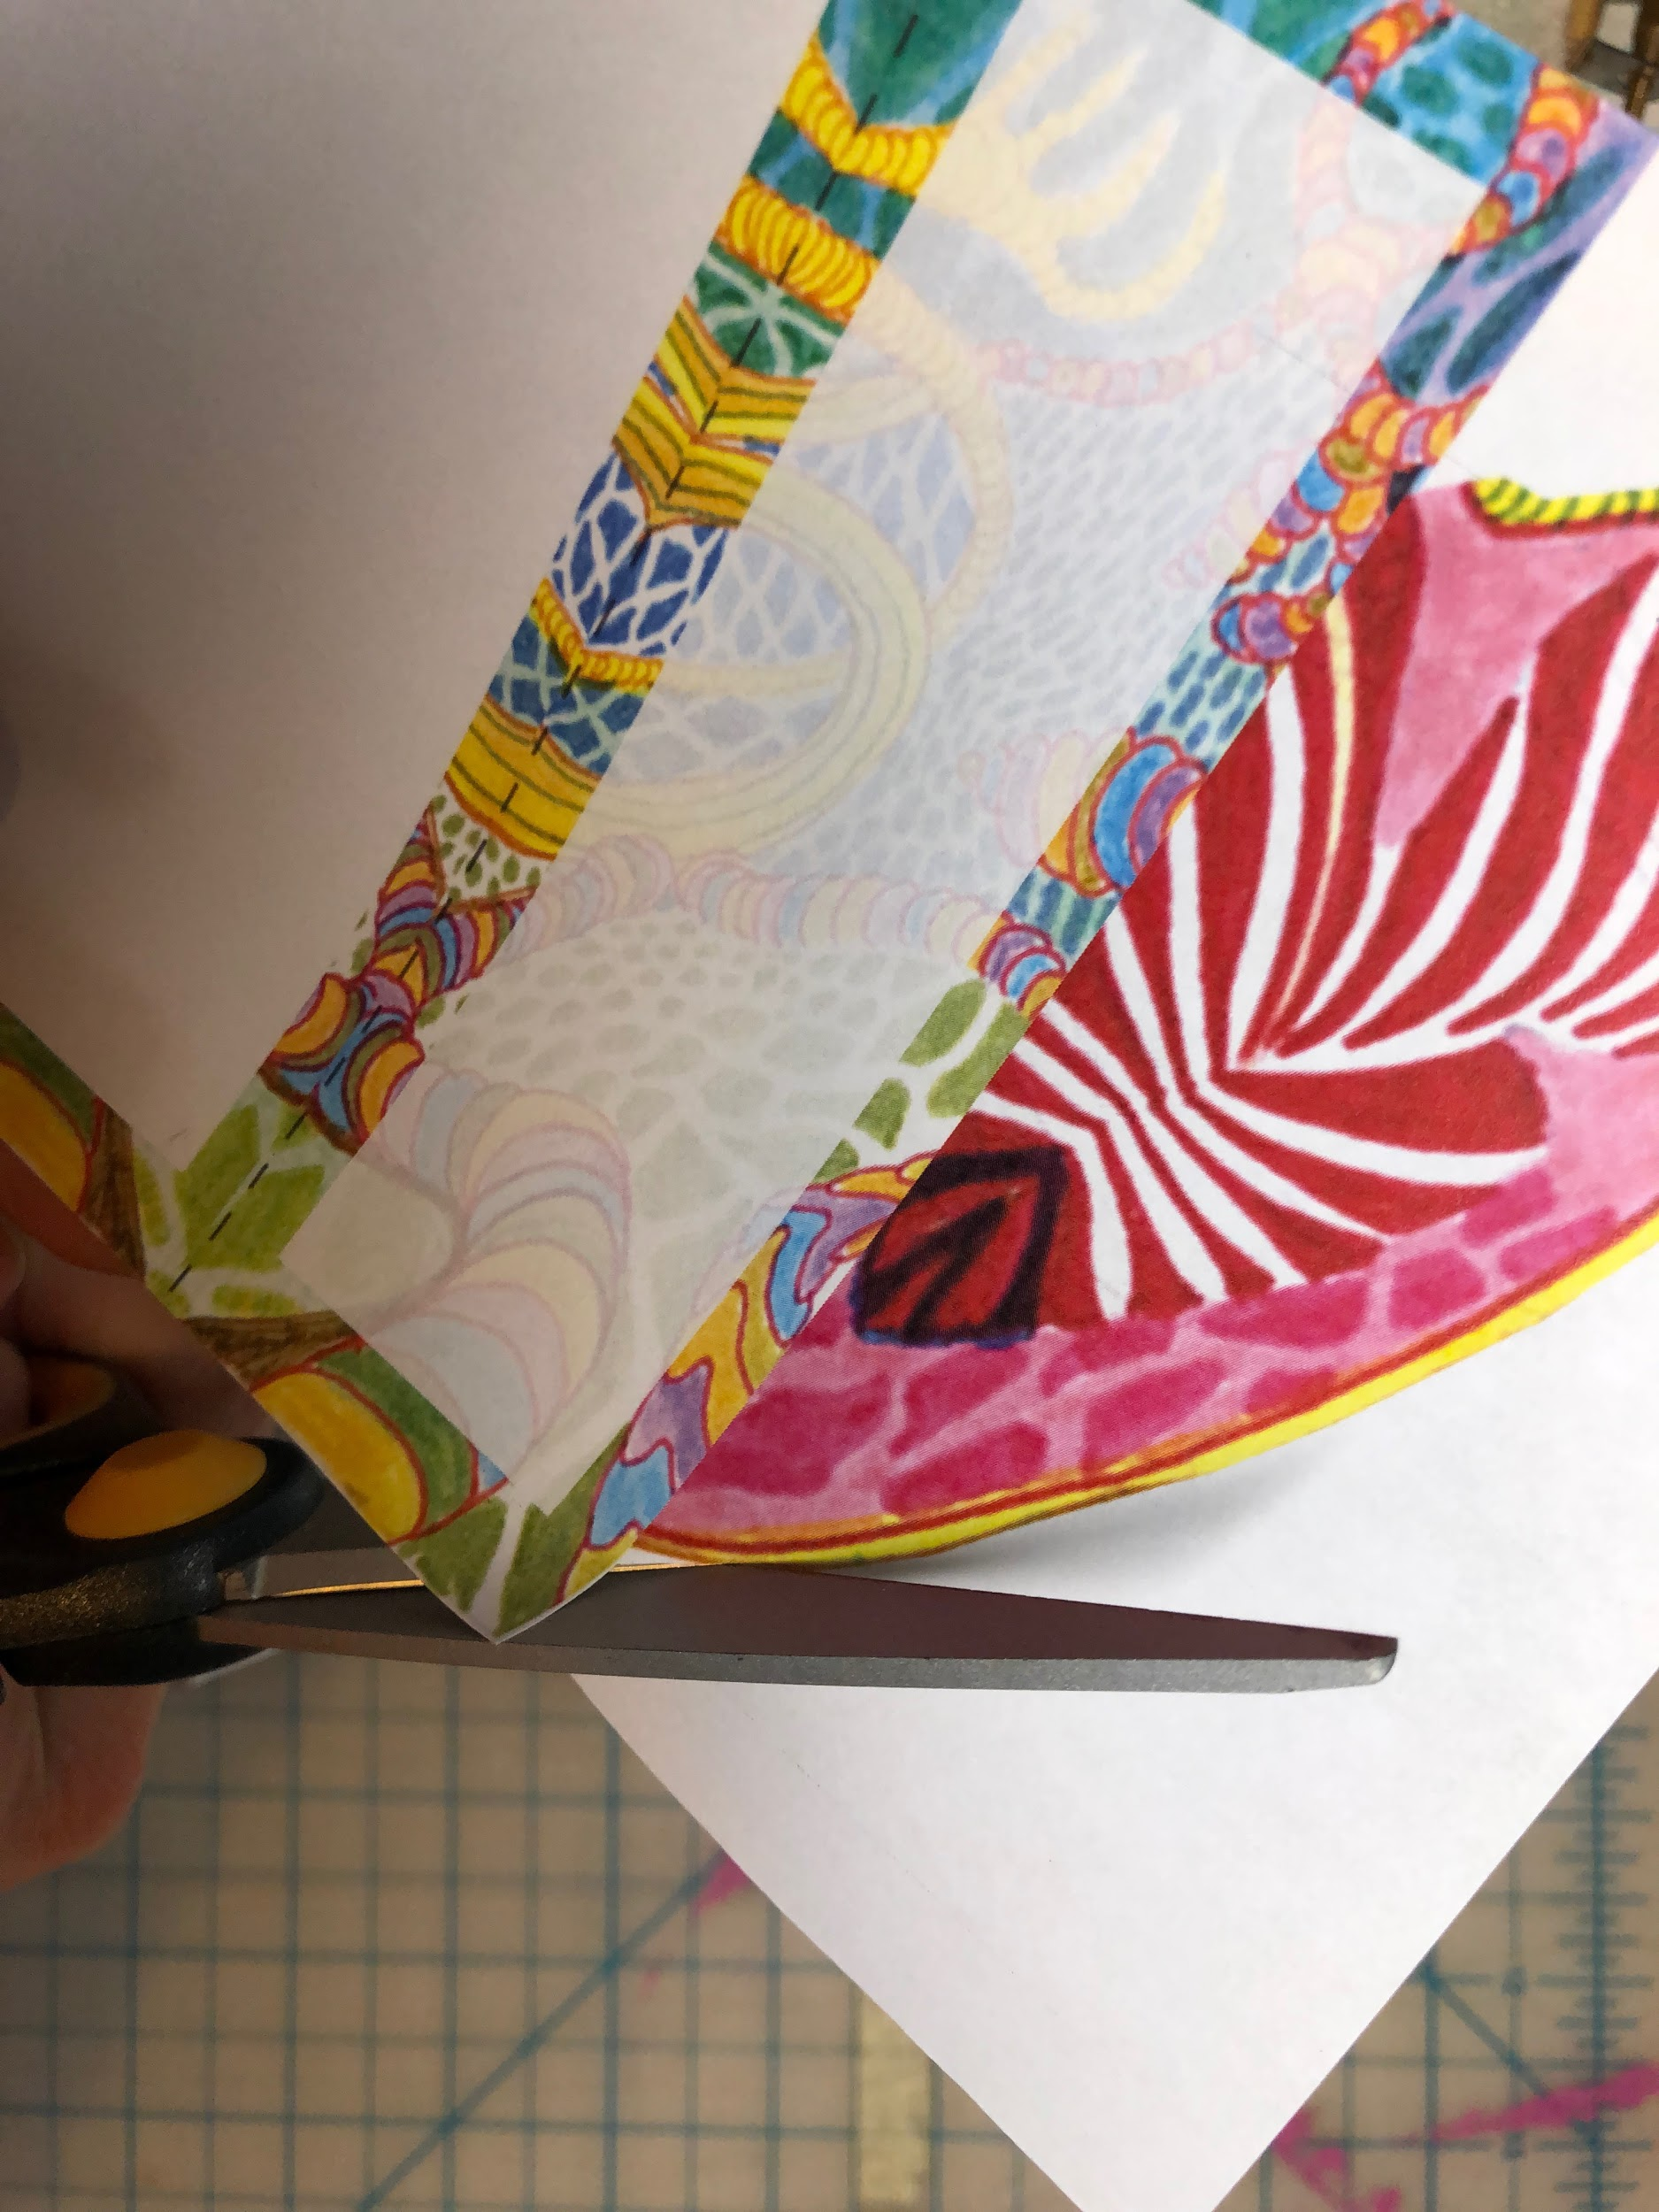  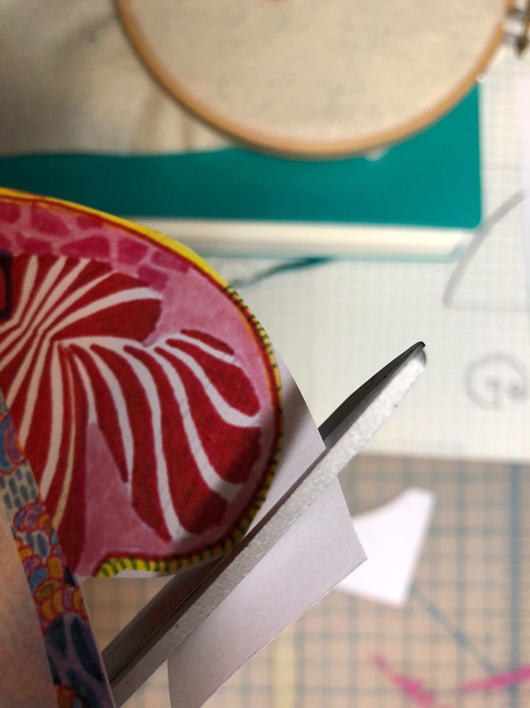
Crease a fold along the line where the heart shape meets the panel on each side of the card. | 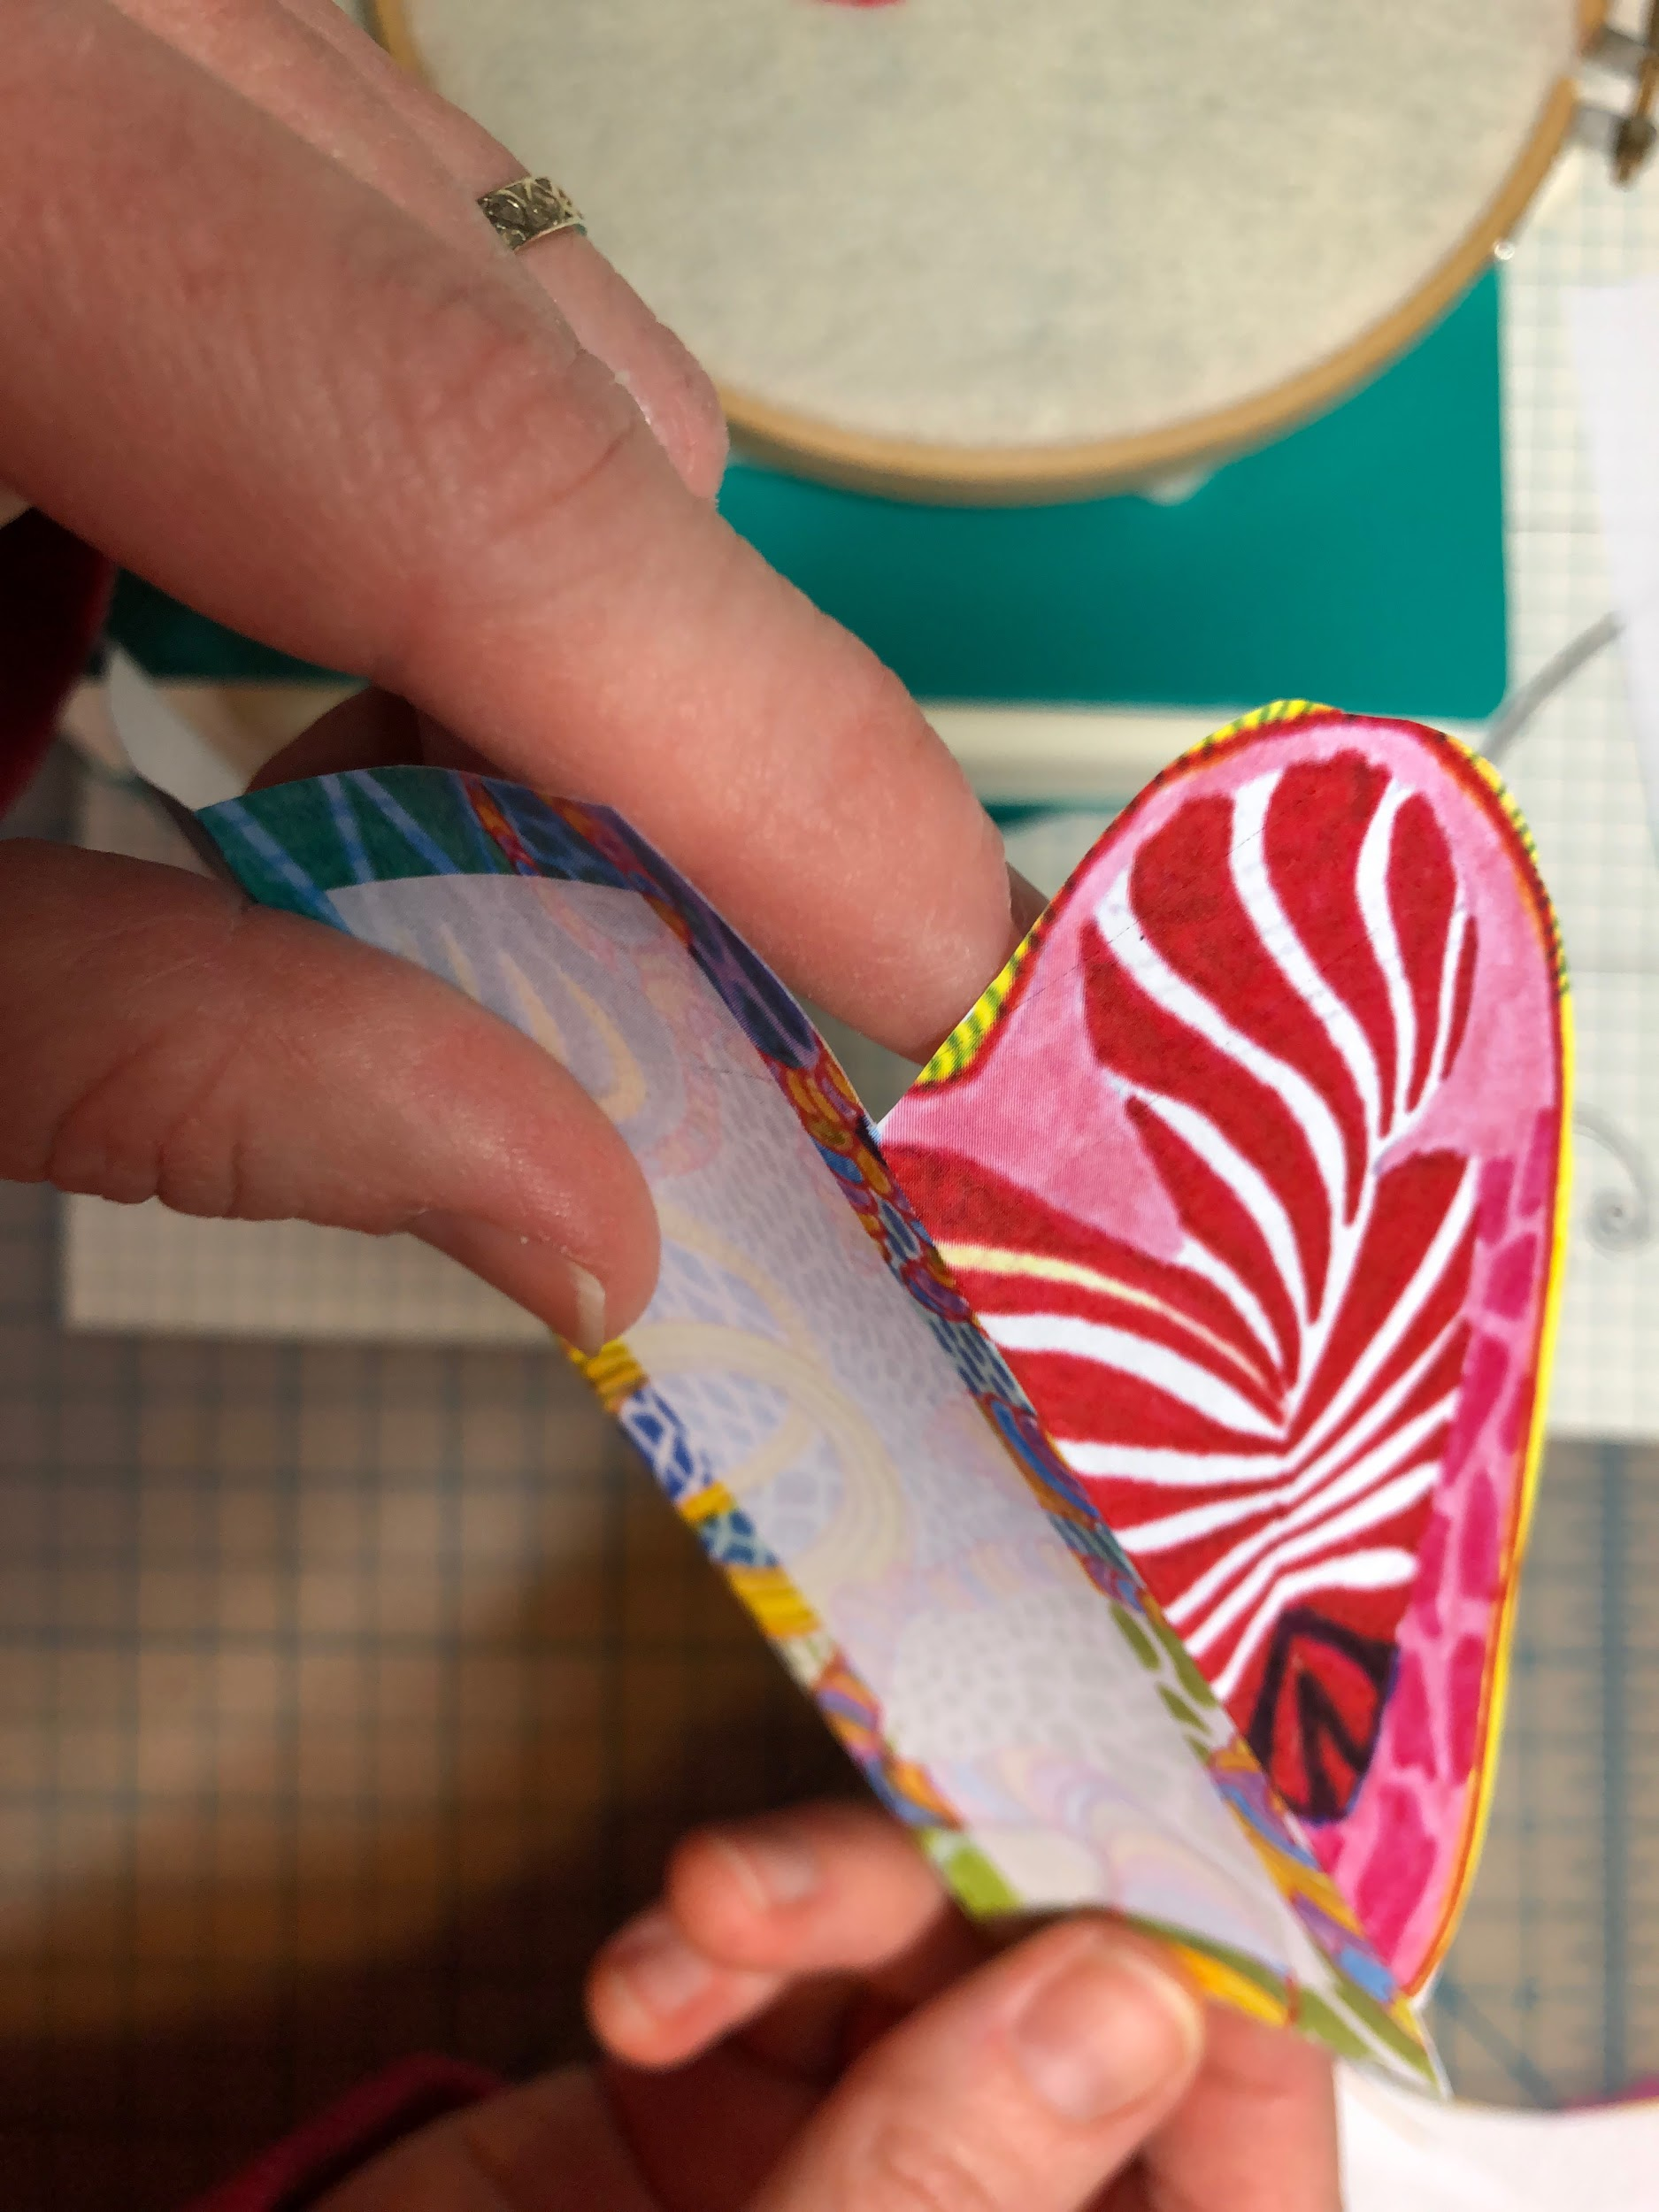
Bring the two folded sides together. | 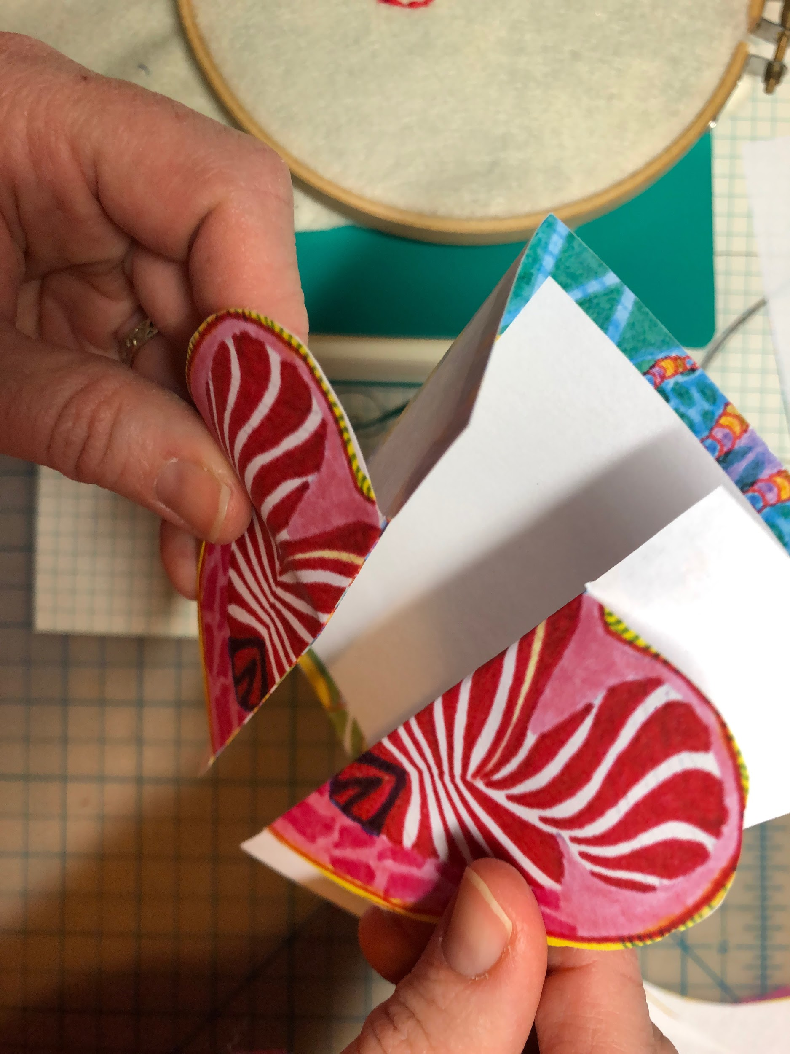
Insert card into envelope. | 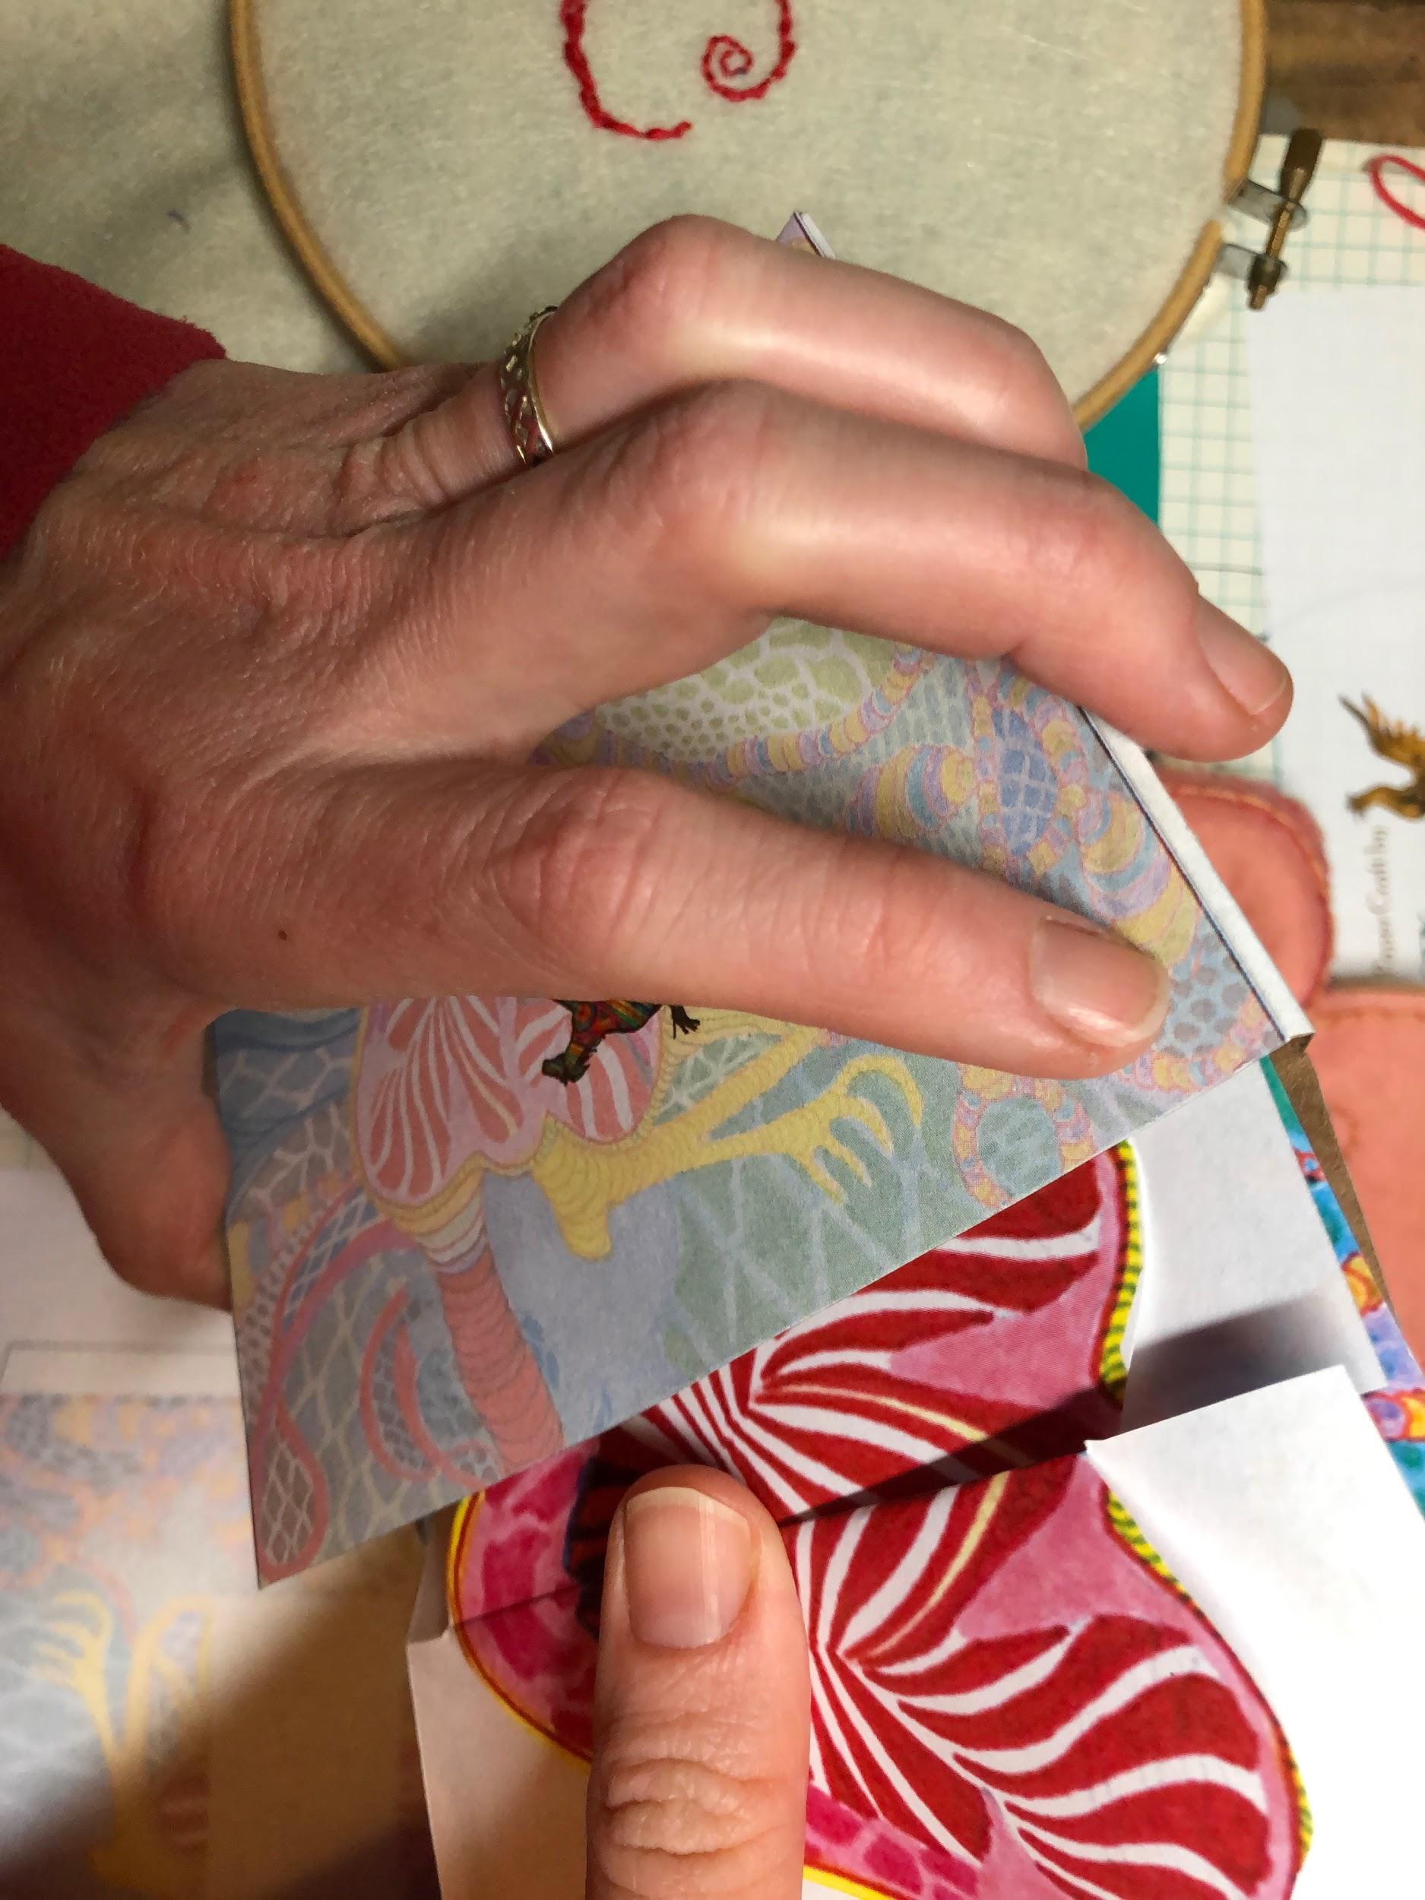

Using MS Word PEEK-A-BOO HEART Valentine

- Open the Word file.
- Click into the empty field in the middle of the card.
- Type your own message.
- Save the file as a Word or PDF file.
- Close the file and attach it to an email to send.

